**Name: Session:**

**Programming II**

**Lab Exercise 2.13.2025**

**Complete the following programs. When you have completed each program, submit a copy of your documented source code. Your documentation should include at a minimum name, assignment number (i.e. Lab Exercise 2.14.2024 Problem 1) and a sample output of your program run.**

1. The Whippet Bus Company charges prices for tickets based on distance traveled, as shown in the accompanying table.

|  |  |
| --- | --- |
| Distance (miles) | Ticket Price ($) |
| 0 – 99 | 25.00 |
| 100 – 299 | 40.00 |
| 300 – 499 | 55.00 |
| 500 and farther | 70.00 |

Write a program that allows a user to enter a trip distance. The output is the ticket price. Save the program as WhippetBus.cs.

1. a. Write a program that prompts the user to make a choice for a pizza size—S, M, L, or X—and then displays the price as $6.99, $8.99, $12.50, or $15.00, respectively. Save the program as PizzaPrices.cs.

b. Modify the PizzaPrices program so that the following discounts apply: no discount for one pizza, 10% for two pizzas, 15% for three or four pizzas, and 20% for five or more pizzas. Display a full accounting of the transaction, similar to that shown below. Save the program as PizzaPrices2.cs.

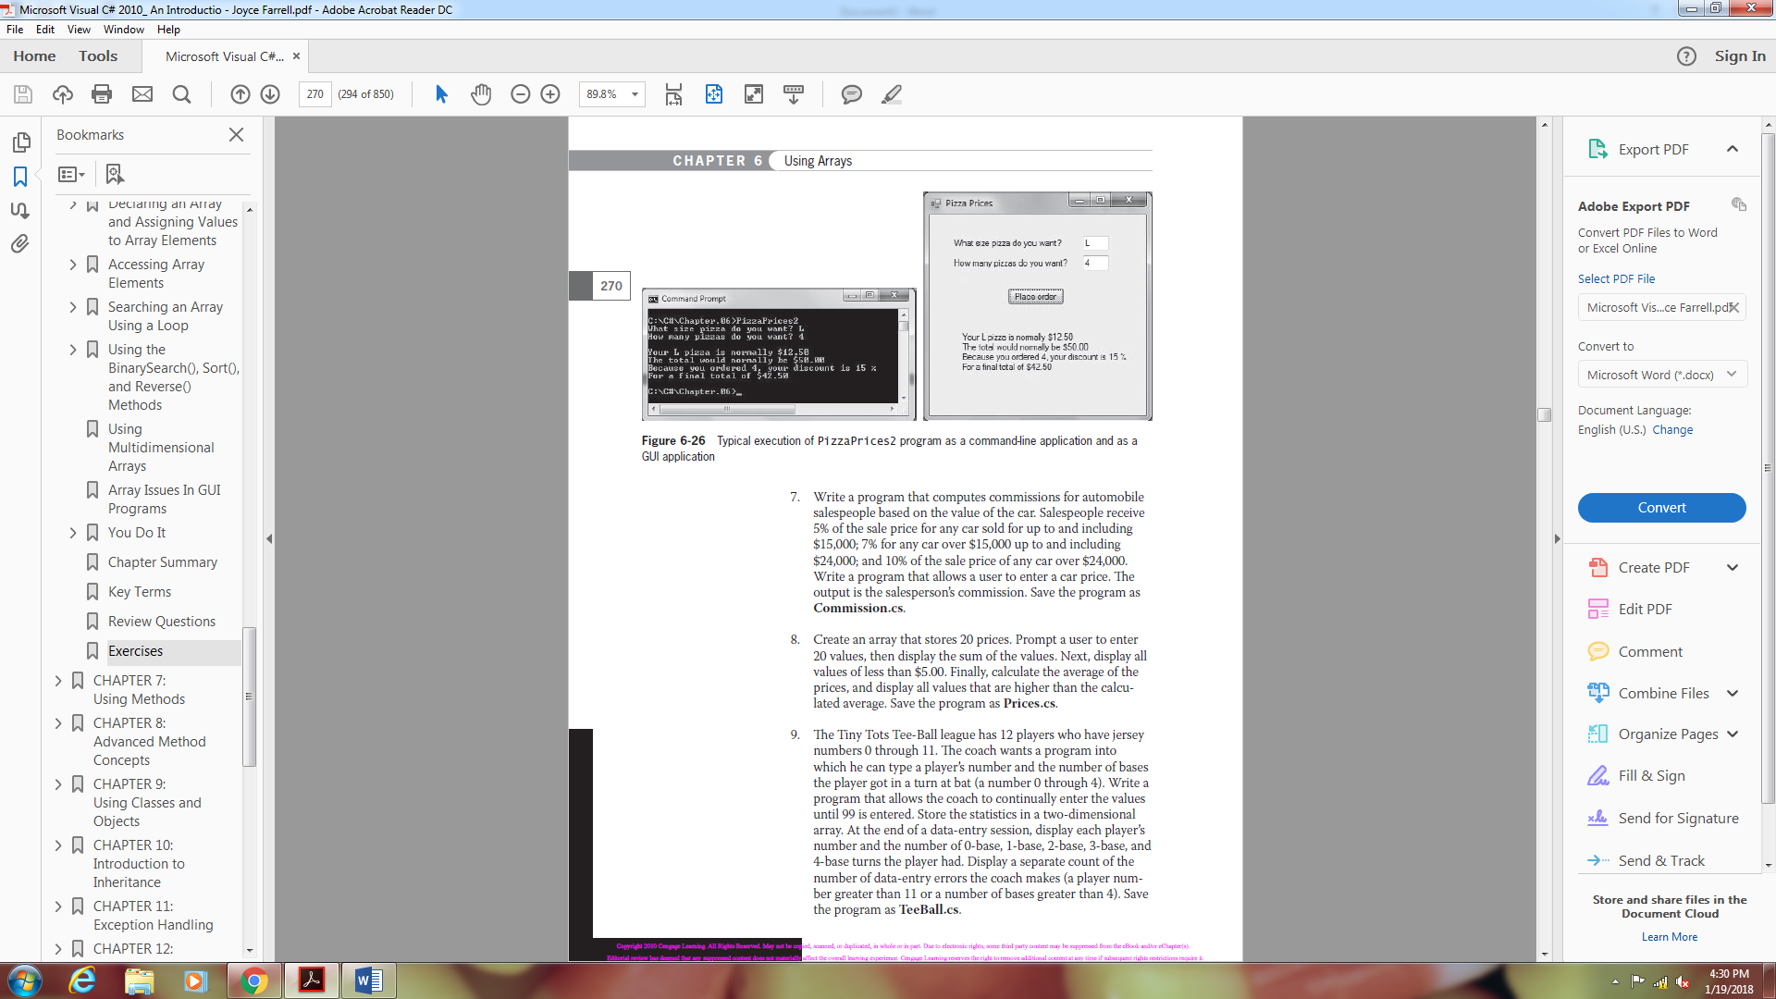

1. Write a program that computes commissions for automobile salespeople based on the value of the car. Salespeople receive 5% of the sale price for any car sold for up to and including $15,000; 7% for any car over $15,000 up to and including $24,000; and 10% of the sale price of any car over $24,000. Write a program that allows a user to enter a car price. The output is the salesperson’s commission. Save the program as Commission.cs.
2. Create an array that stores 20 prices. Prompt a user to enter 20 values, then display the sum of the values. Next, display all values of less than $5.00. Finally, calculate the average of the prices, and display all values that are higher than the calculated average. Save the program as Prices.cs.
3. The Tiny Tots Tee-Ball league has 12 players who have jersey numbers 0 through 11. The coach wants a program into which he can type a player’s number and the number of bases the player got in a turn at bat (a number 0 through 4). Write a program that allows the coach to continually enter the values until 99 is entered. Store the statistics in a two-dimensional array. At the end of a data-entry session, display each player’s number and the number of 0-base, 1-base, 2-base, 3-base, and 4-base turns the player had. Display a separate count of the number of data-entry errors the coach makes (a player number greater than 11 or a number of bases greater than 4). Save the program as TeeBall.cs.